Date 09/02/2026
Dear Parents and Carers,
As we approach the end of Year 9, it is time for our students to make an important decision regarding their GCSE options. I am writing to outline the process for 2026 and explain how we will support your child through this crucial stage.
Our New 2025/2026 Pre-Option Rotation Model
This year, we have introduced a Pre-Option rotation model which gave students increased exposure to the four subjects they were most interested in pursuing. This was designed to provide early insight into different subject areas and to strengthen the quality of their decision making ensuring their choices are well informed.
To further enhance this experience, week commencing 23 February 2026 students will now take part in a five-week mini-rotation, where they will receive targeted information on every available GCSE option. During these sessions, subject leaders will guide students through:
- Each subject’s intent and curriculum design
- The skills required for success
- How the subject will compliment them and support future career progression
This new initiative aims to ensure students not only understand what each subject involves but also why it may be a strong match for their interests, strengths, and ambitions.

Why Are GCSE Options Important?
Selecting GCSE subjects is a pivotal moment for our students, allowing them to tailor their studies to their passions and future goals. Please consider the following when discussing choices with your child:
- Career Alignment: Encourage your child to reflect on possible future pathways. Which subjects will support those aspirations?
- Subject Enjoyment: Enjoyment fuels motivation, which in turn improves academic performance.
- Complementary Choices: Some subject pairings create broader opportunities for future study or careers.
- Avoiding Common Pitfalls: Students should avoid choosing subjects based on popularity, perceived ease, or external pressure. Well researched choices lead to stronger outcomes.

Our Support Process
In addition to the rotations, we also aim to support families through the options process, with the following support steps/resources:
- Options Assemblies: Assemblies and tutor-time presentations will explain course content, expectations, and links to careers.
- Options Booklet & Promotional Videos: All students have access to the online options booklet and video resources. Please explore these materials together at home via the school website.
- Options Evening: Parents and carers are invited to meet staff on Thursday 26 February 2026, from 4:00pm to 6:00pm. Attendance is optional you only need to come if you require further guidance.

Next Steps
Please use the QR code below to register your interest in attending the Options Evening on 26 February 2026. Registration is not a commitment to attend; it simply helps us prepare appropriately.
You will receive a second communication during the week commencing 16 March 2026, with instructions on how to submit your child’s final option choices.
If you have any questions or need further support, please do not hesitate to contact me at cparish@braytonacademy.org.uk.
Let’s work together to ensure our students make informed, confident decisions that set them on a strong path toward future success.
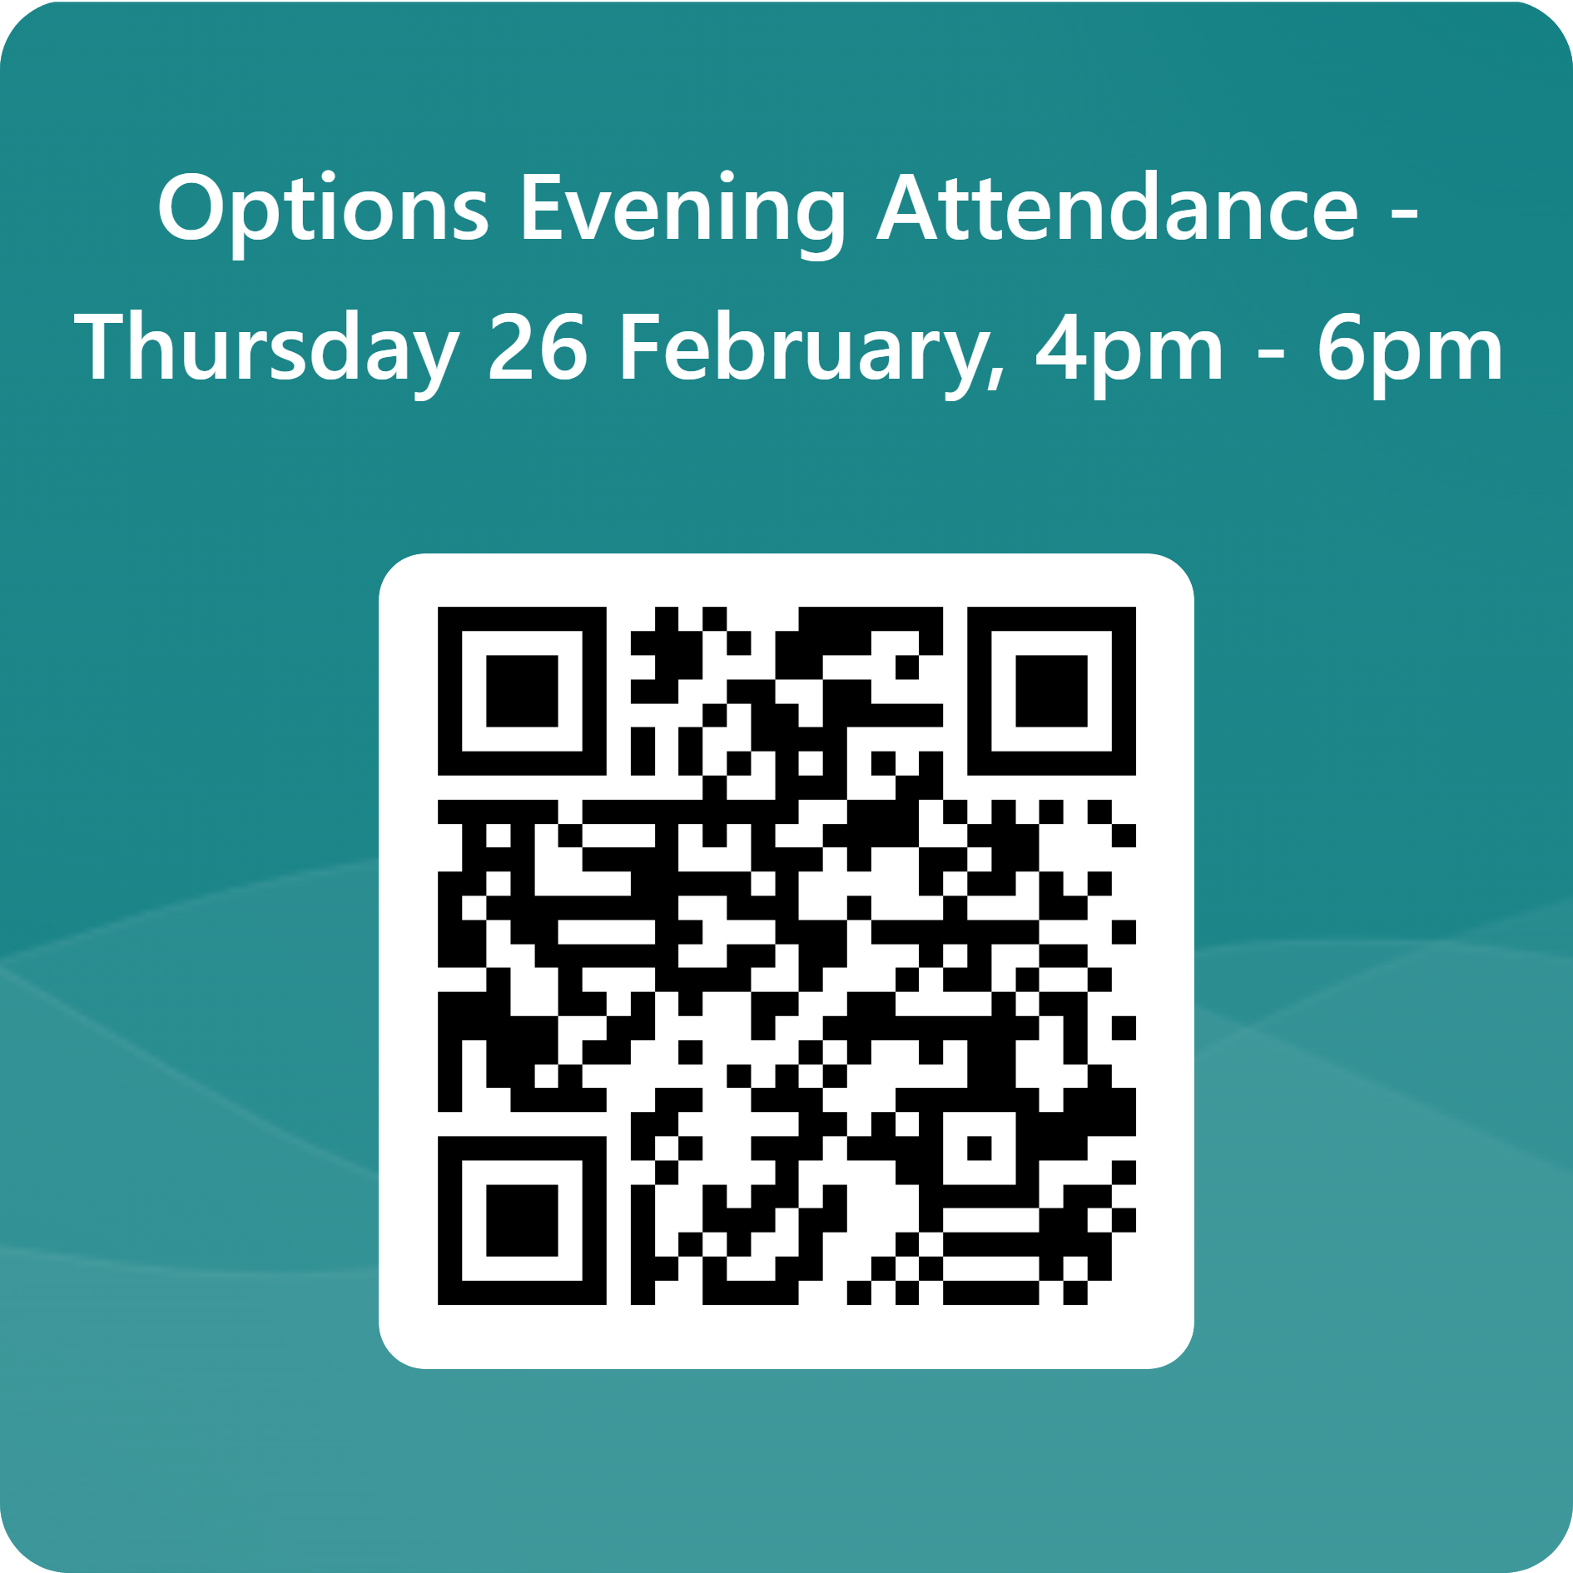
Yours sincerely,
Mr C. Parish
Assistant Principal

Link to form: Options Evening Attendance - Thursday 26 February, 4pm - 6pm – Fill out form

